**Lab#6 Using design of lab 3:**

**a. Implement a category and product management page with insert, update and delete operations.**

**b. Display products on home page from DB to all users.**

**c. If user is logged in then show “more details” on each product and show detailed product description if**

**user clicks “more details.”**

**a. Implement a category and product management page with insert, update and delete operations.**

**Final Outcome:**

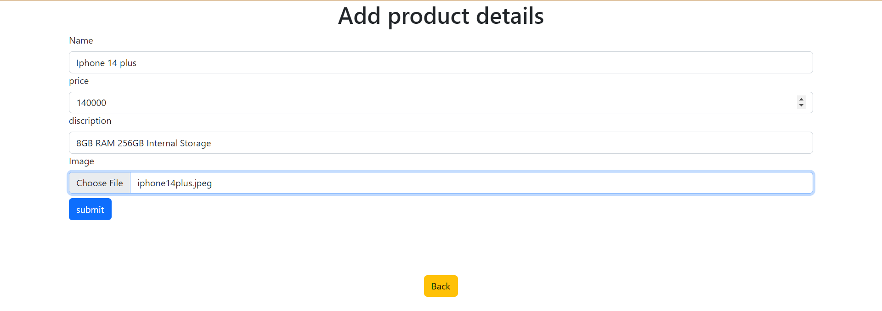

**Code Snippet:**

<!DOCTYPE html>

<html lang="en">

<head>

<meta charset="UTF-8">

<meta http-equiv="X-UA-Compatible" content="IE=edge">

<meta name="viewport" content="width=device-width, initial-scale=1.0">

<title>Document</title>

<link href="https://cdn.jsdelivr.net/npm/bootstrap@5.2.0/dist/css/bootstrap.min.css" rel="stylesheet" integrity="sha384-gH2yIJqKdNHPEq0n4Mqa/HGKIhSkIHeL5AyhkYV8i59U5AR6csBvApHHNl/vI1Bx" crossorigin="anonymous">

</head>

<body>

<?php

include 'db.php';

if(isset($_POST['create']))

$_name = $_POST['name'];

$_price = $_POST['price']; $_discription = $_POST['discription'];

$filename = $_FILES["pfiles"]["name"]; $tempname = $_FILES["pfiles"]["tmp_name"];

$folder = "./uploads/" . $filename;

$query= "INSERT INTO `crud`(`image`, `name`, `Price`, `Discription`) VALUES ('{$filename}','{$_name}','{$_price}','{$_discription}');";

$add_user = mysqli_query($conn,$query);

// displaying proper message for the user to see whether the query executed perfectly or not

if (!$add_user) { echo "something went wrong ". mysqli_error($conn); }

else { echo "<script type='text/javascript'>alert('Product added successfully!')</script>";}}?>

<h1 class="text-center">Add product details </h1>

<div class="container">

<form action="" method="post" enctype="multipart/form-data">

<div class="form-group">

<label for="user" class="form-label">Name</label>

<input type="text" name="name" class="form-control"> </div>

<div class="form-group">

<label for="email" class="form-label">price</label>

<input type="number" name="price" class="form-control"> </div>

<div class="form-group">

<label for="pass" class="form-label">discription</label>

<input type="text" name="discription" class="form-control"> </div>

<div class="form-group">

<label for="pass" class="form-label">Image</label>

<input type="file" name="pfiles" class="form-control"> </div>

<div class="form-group">

<input type="submit" name="create" class="btn btn-primary mt-2" value="submit"> </div> </form>

<div class="container text-center mt-5">

<a href="home.php" class="btn btn-warning mt-5"> Back </a> </div>

</body>

</html>

**Code Snippet**

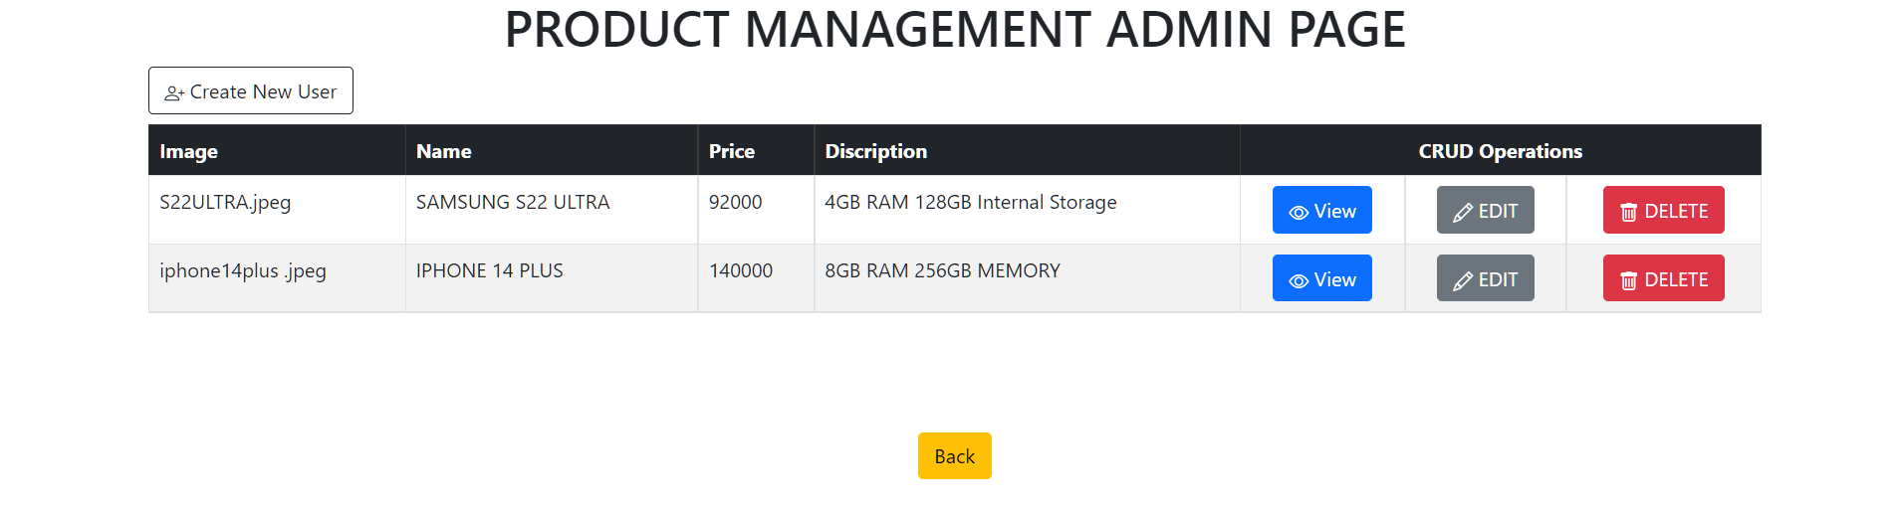

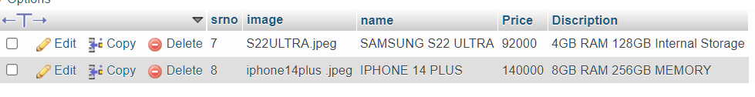

<!-- Header -->

<?php include "db.php"; ?>

<?php include "header.php"; ?>

  <div class="container">

    <h1 class="text-center" >Data to perform CRUD Operations</h1>

      <a href="create.php" class='btn btn-outline-dark mb-2'> <i class="bi bi-person-plus"></i> Create New User</a>

        <table class="table table-striped table-bordered table-hover">

          <thead class="table-dark">

            <tr>

              <th  scope="col">Image</th>

              <th  scope="col">Name</th>

              <th  scope="col">Price</th>

              <th  scope="col"> Discription</th>

              <th  scope="col" colspan="3" class="text-center">CRUD Operations</th>

            </tr>

          </thead>

            <tbody>

              <tr>

          <?php

            $query="SELECT * FROM `crud`";               // SQL query to fetch all table data

            $view_users= mysqli_query($conn,$query);    // sending the query to the database

            //  displaying all the data retrieved from the database using while loop

            while($row= mysqli_fetch_assoc($view_users)){

              $user = $row['name'];

              $email = $row['Price'];

              $pass = $row['Discription'];

              $id ;

              echo "<tr >";

              echo " <td>  {$id} </td>";

              echo " <td > {$user}</td>";

              echo " <td > {$email}</td>";

              echo " <td >{$pass} </td>";

              echo " <td class='text-center'> <a href='view.php?user_id={$id}' class='btn btn-primary'> <i class='bi bi-eye'></i> View</a> </td>";

              echo " <td class='text-center' > <a href='update.php?edit&user_id={$id}' class='btn btn-secondary'><i class='bi bi-pencil'></i> EDIT</a> </td>";

              echo " <td  class='text-center'>  <a href='delete.php?delete={$id}' class='btn btn-danger'> <i class='bi bi-trash'></i> DELETE</a> </td>";

              echo " </tr> ";}  ?>

              </tr>

            </tbody>

        </table>

  </div>

<!-- a BACK button to go to the index page -->

<div class="container text-center mt-5">

      <a href="../index.php" class="btn btn-warning mt-5"> Back </a>

    <div>

<!-- Footer -->

<?php include "footer.php"; ?>

**b. Display products on home page from DB to all users.**

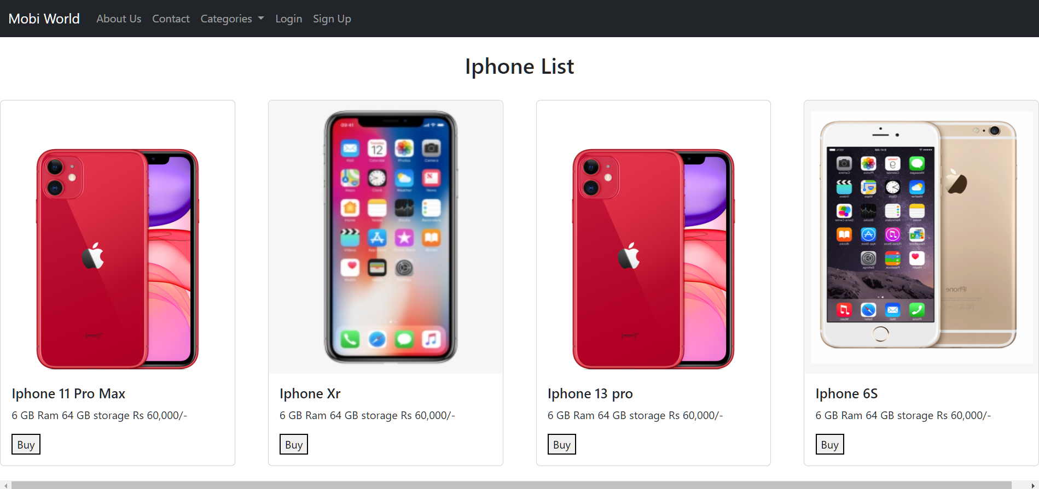

**code snippet :**

<?php include “header.php;”?>

          <?php

            $query="SELECT * FROM `crud`";               // SQL query to fetch all table data

            $view_users= mysqli_query($conn,$query);    // sending the query to the databas

            while($row = mysqli_fetch_assoc($view_users))

            {

              $id = $row['image'];

              $user = $row['name'];

              $email = $row['Price'];

              echo "<tr >";

              echo " <td>  {$id} </td>";

              echo " <td > {$user}</td>";

              echo " <td > {$email}</td>";

              echo " <td class='text-center'> <a href='view.php?user_id={$id}' class='btn btn-primary'> <i class='bi bi-eye'></i> View</a> </td>";

              echo " <td class='text-center' > <a href='update.php?edit&user_id={$id}' class='btn btn-secondary'><i class='bi bi-pencil'></i> EDIT</a> </td>";

              echo " <td  class='text-center'>  <a href='delete.php?delete={$id}' class='btn btn-danger'> <i class='bi bi-trash'></i> DELETE</a> </td>";

              echo " </tr> ";}  ?>

              </tr>  </tbody>

</table>  </div>

<?php include “fotter.php;” ?>

**c. If user is logged in then show “more details” on each product and show detailed product description if**

**user clicks “more details.”**

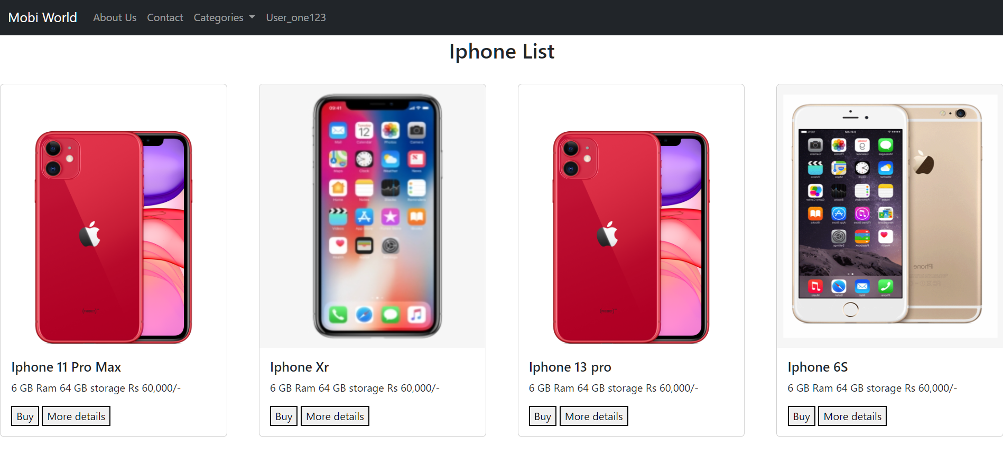

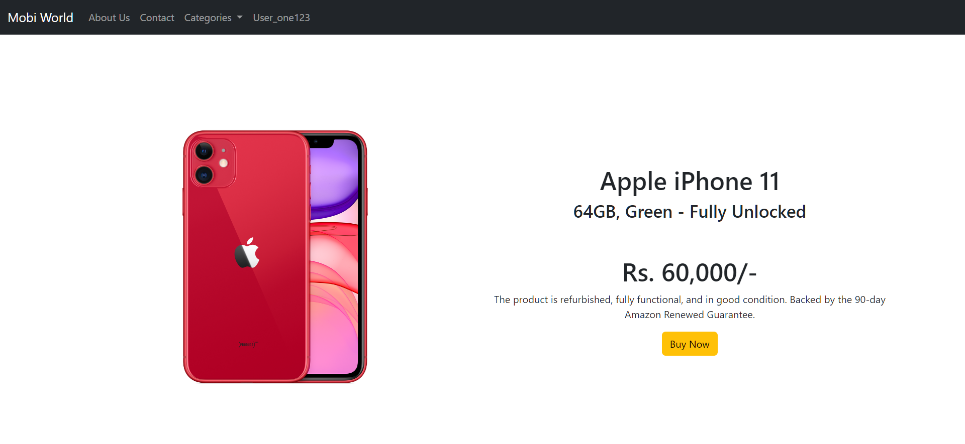

<?php include “navigationbar.php”;

Include “config.php”

$_session.start();

$_session_name = $id;

$sql = “select * from `mobiworld`;

$result = mysqli_query($conn, $sql);

Isset($_post[‘moredetail’]{

if(isset($_POST['submit'])) {

$_p_name = $_POST['name'];

$_p_price = $_POST['price'];

$_p_description = $_POST['description'];

$_p_file = $_POST['file']; ?>

<br> <br><br><br>

<?php

echo $_p_name;

$insert_sql = "INSERT INTO `products`(`name`, `price`, `discription`, `discount`, `category`, `pimage`) VALUES ('$_p_name','$_p_price','$_p_description','$_p_discount','$_p_category','$_p_file');";

$result = mysqli_query($conn, $insert_sql);

if(isset($result)){

echo ' <h1 style="border: 4px solid black; background-color: rgb(121, 218, 147); color: rgb(6, 120, 55); width:900px; display: flex; justify-content: center; align-items: center;text-align: center;font-size: xx-large;" >Product Added sccessfully</h1>';

} else {

echo ' <h1 style="border: 4px solid black; background-color: rgb(121, 218, 147); color: rgb(6, 120, 55); width:900px; display: flex; justify-content: center; align-items: center;text-align: center;font-size: xx-large;" >Error adding product</h1>’; }}

$select_sql = "SELECT * FROM `products`";

$queryfire = mysqli_query($conn,$select_sql);

$num = mysqli_num_rows($queryfire);

if($num > 0) {

while($product = mysqli_fetch_array($queryfire)) {

?>

<td><?php echo $_p_name; ?></td>

<td><?php echo $_p_price; ?></td>

<td><?php echo $_p_description; ?></td>

<td><?php echo $_p_discount; ?></td>

<td><?php echo $_p_category; ?></td>

<td><?php echo $_p_file; ?></td>

<td><input type="button" value="Update"><br> <input type="button" value="Delete"></td>

</tr>

<?php }} $_session.close(); ?>

</table>

<script src="https://cdn.jsdelivr.net/npm/bootstrap@5.2.0/dist/js/bootstrap.bundle.min.js" integrity="sha384-A3rJD856KowSb7dwlZdYEkO39Gagi7vIsF0jrRAoQmDKKtQBHUuLZ9AsSv4jD4Xa" crossorigin="anonymous"></script>

</body>

</html>